MacLan’s Maine Coon Cattery
Sales Agreement

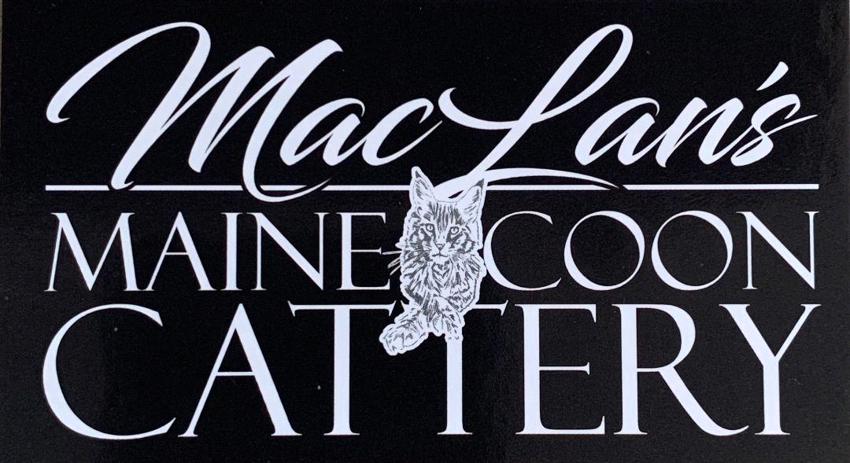

Purchaser Name:
Address:
Phone:
Email Address:

Description on Kitten- MACLANS _(kitten name)_ (standard/polydactyl paws)
Color/pattern: Sex: Male/Female
Birthdate: TICA Reg. # To be determined when registered
Sire:
Dam:

TOTAL PRICE: $Total Amount of Kitten
Reservation Payment: $Half of Total
Make check/money order payable to: “MacLan’s Maine Coon Cattery” or “Nate or Laura Lamberth”.
If paying by Venmo @MacLansMCC.
If paying with Cashapp $MacLansMCC.
If paying by PayPal, send as friends only (paypal fees to be paid by the purchaser) to n.lamberth@yahoo.com

Any funds collected between now and go home day will be deducted from the remaining balance due if you prefer to send partial payments for the remaining balance. Any balance that is paid at pickup, must be cash and a receipt will be provided. If you plan to pay balance using paypal, Venmo, Cashapp, personal check or money order, it must be received two weeks prior to go home date. The reservation fee and signed contract is due back in one weeks time, and due by _________________. Please be aware that we will have to move on with another family if you are unable to return by the date listed above.

Breeder: MacLan’s Maine Coon Cattery
Nathaniel and Laura Lamberth
Mailing address will be provided

Phone: 606-669-3932 email: maclansmcc@yahoo.com website: maclansmainecoons.com

MacLan's Maine Coon Cattery (Breeder/Seller) guarantees that the cat listed above is a purebred Maine Coon, with an accurate pedigree, and is eligible for registration with The International Cat Association (TICA). TICA registration paperwork will be given to you when your baby comes home. You may register your kitten under whatever name you choose as long as it does not exceed the number of characters allowed by TICA, and the name has not been previously used.

All kittens have been raised in our home with our family and other pets (other cats and dogs). Kittens will be well socialized and if any temperament issues are noted, they will be discussed prior to acquisition. If Buyer is apprehensive of any issues/personality traits, Buyer may move their deposit to another kitten, when one is available.

MEDICAL HISTORY & GUARANTEES

HEALTH GUARANTEE
Kittens will not be placed in their new homes for at least 14-16 weeks after birth. Kittens will have at least 3 veterinarian visits and be given a general health examination prior to acquisition at the spay/neuter appointment. Your kitten’s health record will be provided to you and should be taken to your first veterinarian visit. Please keep up with the health record as we do not have a duplicate copy.

Buyer agrees to quarantine the kitten for 14 calendar days from all other household pets. If kitten is exposed to other pets or allowed outside, the health guarantee will be null and void. MacLan’s cannot guarantee the health of a kitten that has been exposed to other animals that are potentially carriers of diseases they are not currently symptomatic from.

This kitten is guaranteed to be free of any internal or external parasites on the date of sale. Kittens are de-wormed as a preventative measure, even if found negative on fecal sample testing. If within 2 weeks of acquisition, your veterinarian determines by fecal sample test results that your kitten has a parasite, the Breeder agrees to pay for treatment up to $100.00. Buyer agrees to provide a written report, signed by the examining licensed veterinarian and copy of bill for cost associated with treatment. The buyer will only be refunded for treatment when these things are provided.

The Buyer must administer a flea and tick treatment of your choice as recommended by your veterinarian. MacLan’s uses Revolution brand as directed by manufacturer according to weight of animal. We have likely treated your kitten prior to going home with flea and tick treatment and is noted on the health record. Please check this before applying for the first time.

All kittens have had a minimum of three veterinarian visits and all required vaccinations administered. Administered vaccinations are listed in the health record and given three times by time of kitten acquisition. Rabies is also given by our veterinarian. An additional vaccination will be needed around 20 weeks of age. You agree to provide all vaccinations to your kitten as recommended by your veterinarian when due.

Breeder guarantees the kitten to be in good health at the time of acquisition. To fulfill this guarantee, you agree to have your kitten screened and checked by a licensed vet within 3 working days from receipt of kitten. If the veterinarian, upon examination of the kitten, determines that serious illness was present at or prior to sale, the breeder must be contacted prior to treatment (except in emergency situations). Buyer agrees to provide a written report, signed by the examining licensed veterinarian, including the diagnosis and all test results the diagnosis is based on. The Breeder has the right to request a second opinion from a veterinarian of the Breeder's choice, at the Breeder's expense. The Buyer, at his/her option and within 5 calendar days of the veterinary diagnosis may elect to return the kitten and accept a replacement kitten, when it becomes available. The Breeder may, at his/her option and within the same five-day period, elect to cancel this sales agreement and refund the purchase price to the Buyer with the return of the cat/kitten when health issues arise. All costs associated with shipping/return of the cat/kitten will be the responsibility of the Buyer.

Breeder does not guarantee or refund any stress related illnesses. A new home can be very stressful and can trigger symptoms such as an upper respiratory infection or diarrhea. Breeder agrees to offer any support/advice within means to help with transition. Buyer agrees to follow guidance provided to transition your new kitten into your home.

It is the responsibility of the Buyer to provide immediate veterinary care for the cat/kitten showing signs of illness or distress, and failure to do so will render any guarantee null and void. Under no circumstances is a cat/kitten to be destroyed/euthanized prior to notification by the Buyer to the Breeder. If the cat/kitten dies within the first year despite medical treatment, replacements will be made only if a licensed veterinarian certifies the cause of death to be a fatal congenital defect. This claim would require submission of vet records, including but not limited to complete medical records, necropsy report, x-rays, written certification of cause of death and return of the registration papers. Claims are subject to verification by the Breeder's veterinarian.

Purchasing insurance is ideal as the only funds that would be paid to you in the event of a major medical issue covered by the health guarantee is up to the purchase price of the kitten. Did you know you can pay for health insurance for years for the cost of Hip replacement surgery?

Maine Coons are predisposed to have Hip Dysplasia (HD) and Hypertrophic Cardiomyopathy (HCM). Even though we do all the testing we can to ensure the parents are clear, this does not guarantee your kitten/cat will not develop it at some point in life. Maine Coons grow rapidly and will be quite large. It is very important that they receive a quality diet and supplemental vitamins. A joint/bone supplement would also be ideal especially while growing. You understand that development of these issues are possible and not within our control. These issues can pass several generations and can be impacted by environment and diet as well.

Maine Coons are also prone to have gingivitis, even though usually juvenile and will not need more than a routine cleaning. It is also possible that extraction of teeth would be needed. Entropion is somewhat more common due to the shape of their face, requiring eye surgery in some cases. Gingivitis and Entropion are not present as small kittens and not something I can test for so it is imperative to understand development of these would be out of my control. I do not practice breeding with cats that have been affected by either but at times, this has developed later in life after retirement of kings and queens.

Parents of kitten have been tested for FeLV and FIV and were negative prior to breeding. At the Buyer’s expense, testing of the kitten can be done prior to purchase. A randomly chosen littermate is also tested during spay/neuter to ensure negative.

There is no guarantee for kittens or cats when tested for Coronavirus as the test is not specific to a single Coronavirus. There is no guarantee if the buyer uses the FIP vaccine, as FIP may be potentiated by such.

Under no circumstances shall the Breeder's liability exceed replacement of the cat/kitten.

Breeder support will be available to the Buyer for any questions regarding this kitten for its entire lifetime.

GENETIC GUARANTEE
The genetic guarantee is good for one year from the date of sale and guarantees the kitten not to have any GENETIC defects severe enough that it prevents the animal from living a normal life as a pet i.e. HCM, Hip Dysplasia requiring corrective surgery. If an illness is discovered within the one year period that is deemed GENETIC in nature, and alters the animals ability to live a normal life as a pet, the Breeder guarantees to replace the animal with another of equal quality when available, or at our discretion offer partial/full refund. Shipping/delivery expenses of the replacement are the responsibility of the Buyer. Monetary refunds will only be given AFTER the family has performed the required testing and the specialist has identified the health concern to be genetic, and that the pet is unable to live life normally. We do not pay for up front testing because many times a vet is guessing what could be wrong without the proper testing. Again, having pet insurance is ideal.

Parents have been genetically tested for the HCM, SMA and PKD gene and found negative.

If at any time, your cat develops sickness that is deemed genetic in nature, even if it does not affect quality of life, please notify us immediately to ensure we continue to produce genetically healthy kittens.

General Provisions:
Buyer agrees that this kitten has been purchased as a family pet. He/she will never be sold, leased, given away, put in an animal shelter, humane society, or sold to any pet shop, research laboratory or similar facility. If, for any reason at all, the buyer cannot maintain ownership, the breeder retains the right of first refusal to re-obtain ownership of the cat/kitten without refund of purchase price and other expenses incurred.

Buyer agrees to be patient with this kitten as it acclimates to the Buyer's home. Breeder can make no guarantees regarding how long it will take for your new kitten to acclimate. Breeder agrees to offer any support/advice possible during this time if needed.

This kitten is sold as an inside pet/show alter only. Allowing the kitten outside unattended could potentially expose your kitten to disease and therefore will void the health guarantee. The use of shock collars, boundary fences or anything similar is prohibited. You agree that in the event you do not follow this agreement and the animal is taken back into our possession to pay for any rehab or treatment the animal should need to recover from the stress.

Declawing of the kitten is not permitted and will void the health guarantee.

Buyer agrees that this kitten/cat will never be left for more than 24 hours by its owner unless arrangements have been made for a responsible person to provide fresh food, water and litter.

You have been/will be sent a personal article titled "I'm Coming Home" prior to acquisition that gives great tips and tricks, food recommendations specific to your kitten and information to make transitioning easier for the kitten and you. Your kitten is currently eating Farmina kitten dry food and a variety of can food. We recommend Life’s Abundance dry food mixed with Farmina dry food after we fully wean them around 8-10 weeks of age. For wet foods, we like Farmina, Wellness Core, Earthborne, Merrick and Life’s Abundance brands.

Buyer agrees to resolve any and all issues in private and will not publicly disclose private conversations, screen shots or emails exchanged between the two parties.

The Breeder reserves the right to cancel this contract for any reason up to the point of Buyer taking possession of the kitten. In the event that this contract is cancelled by the Breeder, all funds received will be refunded within 1 week by money order/cashier’s check to the original remitter.

Any legal fees incurred in upholding this contract will be paid by the Buyer. Venue is in the State of Kentucky, Lincoln County.

We, the signing parties consider this document to be legally binding. Both the Buyer and Breeder must initial the bottom of each page of this agreement and any changes to this agreement.

I AM IN FULL AGREEMENT AND AGREE TO ABIDE BY THE TERMS AND CONDITIONS OF THIS SALES AGREEMENT.

Breeder Signature:

________________________________ __________
MacLan’s Maine Coon Cattery Date
Breeders: Nate and Laura Lamberth

Buyer Signature:

_________________________ __________ _______________________ ___________
Buyer Date Buyer Date

